Program 1:

#include<iostream>

using namespace std;

void divide(double x, double y) {

cout<<"Inside Function\n";

try {

if(y==0.0)

throw y;

else

cout<<"Division = "<<x/y<<endl;

}

catch(double) {

cout<<"Caught double inside function\n";

throw;

}

cout<<"End of function\n";

}

int main() {

cout<<"Inside main\n";

try {

divide(10.5,2.0);

divide(20.0,0.0);

}

catch(double) {

cout<<"Caught double inside main\n";

}

cout<<"End of main"<<endl;

return 0;

}

Output:

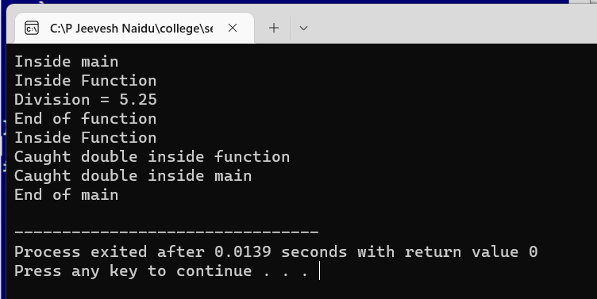

Program 2:

#include<iostream>

using namespace std;

void test(int x) {

try {

if(x==1) throw x;

else

if(x==0) throw 'x';

else

if(x==-1) throw 1.0;

cout<<"End of try-block\n";

}

catch(char c) {

cout<<"Caught a character\n";

}

catch(int m) {

cout<<"Caught a integer\n";

}

catch(double d) {

cout<<"Caught a double\n";

}

cout<<"End of try-catch system\n\n";

}

int main() {

cout<<"Testing Multiple catches\n";

cout<<"x = 1\n";

test(1);

cout<<"x = 0\n";

test(0);

cout<<"x = -1\n";

test(-1);

cout<<"x = 2\n";

test(2);

return 0;

}

Output:

